A MINOR PROJECT REPORT
ON
“Second hand book reselling website”

Submitted in Partial Fulfillment for the award of
Bachelor of Technology in Computer Science & Engineering
(2022-2023)


Submitted to
RAJIV GANDHI PROUDYOGIKI VISHWAVIDYALAYA
BHOPAL (M.P.)


Submitted By:-
Om Gupta(0302CS201051)
Mahendra Ravi(0302CS2010xx)
Dheerendra Singh(0302CS2010xx)
Anil Vishwakarma(0302CS201015)

Approved By Under the Guidance of
Mr. Bhanu Pratap Singh Mr. C.P.Gautam
(HOD CSE Department) (Asst. Prof. CSE Department)
Ms. Sakshi Singh
(Asst. Prof. CSE Department)
DEPARTMENT OF COMPUTER SCIENCE & TECHNOLOGY
VINDHYA INSTITUTE OF TECHNOLOGY AND SCIENCE
SATNA (M.P.)

Rajiv Gandhi Proudyogiki Vishwavidyalaya, Bhopal (M.P)
Vindhya Institute of Technology & Science
Satna (M.P)


CERTIFICATE

This is to certify that the Minor Project on “Second hand book reselling website” which has been completed & submitted by Dhirendra Singh, Mahendra Ravi, Om gupta, Anil Vishwakarma in partial fulfillment of the requirement for the award of the degree of Bachelor of Technology in Computer Science & Engineering for the session 2022-2023 is a bonafied work by them and has been completed under my guidance and supervision.

H.O.D Guided By
Mr. Bhanu Pratap Singh Mr. C.P.Gautam
(HOD CSE Department) (Asst. Prof. CSE Department)
Ms. Sakshi Singh
(Asst. Prof. CSE Department)

Principal
Dr. P.K.Shukla

Rajiv Gandhi Proudyogiki Vishwavidyalaya, Bhopal (M.P)
Vindhya Institute of Technology & Science
Santa (M.P)

CERTIFICATE

This is to certify that the Minor Project on “Second hand book reselling website” which has been completed & submitted by Dhirendra Singh, Mahendra Ravi, Om Gupta and Anil Vishwakarma in partial fulfillment of the requirement for the award of the degree of Bachelor of Technology in Computer Science & Engineering for the session 2022-2023.

(External Examiner) (Internal Examiner)

DECLARATION

We hereby declare that the work which is being presented in the project report entitled “Second hand book reselling website” partial fulfillment of the requirement of the degree of “Bachelor of Technology in Computer Science & Engineering” branch is an authentic record of our work carried out under the guidance of “Mr.C.P.Gautam and Ms. Sakshi Singh”. The work has been carried out at Vindhya Institute of Technology & Science, Satna.

Project Associate
Om Gupta(0302CS2010xx)
Mahendra ravi(0302CS2010xx)
Dheerendra Singh(0302CS2010xx)
Anil Vishwakarma(0302CS2010015)

ACKNOWLEDGEMENT

A project like this one involves many people and would be incomplete without the mention of all those people whose guidance and encouragement helped in the successful completion of this project.
I would like to express my sincere and deep sense of gratitude from my heart to my guide and project coordinator Mr. C.P.Gautam and Ms. Sakshi Singh, Assistant Professor, VITS, Satna (M.P.), for his help supervision and encouragement as a guide throughout the course of this investigation.
With great pleasure and deep sense of gratitude I would like to express my special thank to Mr. Bhanu Pratap Singh, Head of Department of Computer Science & Engineering, VITS, Satna, for his erudite guidance, affectionate encouragement and wholehearted involvement in my thesis, without which it would have been difficult for me to complete this work. I am fortunate to be his student.
I would like to take this opportunity to offer my special thank to Mr. Sunil Senani, Chairman, VITS, Satna for his constant encouragement and bearing with me and light up my path.
I express my deepest gratitude to Dr. P.K.Shukla, Principal of the VITS, Satna for encouragement, useful suggestions and inspiration for completing my thesis.
I would like to express the special thanks to all faculty members and the staff of the Department of Computer Science. They are excellent teacher and have inspired me to continue learning with an open and positive mind.
I express my heartfelt gratitude to my friends and also to each and every individual who was associated with my work, including those whom I may have inadvertently failed to mention.
Finally, I am highly obliged to all my family members for their support and blessings.
Om Gupta(0302CS2010xx)
Mahendra ravi(0302CS2010xx)
Dheerendra Singh(0302CS2010xx)
Anil Vishwakarma(0302CS2010015)

Table of Content

CHAPTER 1 INTRODUCTION | Page range like (2-8)
1.1 Evaluation of System | Page no.
1.2 Problem definition | Page no.
1.3 Proposed System | Page no.
1.4 Scope of work/project | Page no.
1.5 Report Organization | Page no.
CHAPTER 2 LITERATURE SURVEY | Page range like (2-8)
2.1Presently available system | Page no.
2.2 Title/ Article | Page no.
2.3 Name of Author/ Name of web site/Book | Page no.
2.4 ISSN no. of Paper/Journal / Complete URL of website/ISBN No. of Book | Page no.
2.5 Conclusion: Include required facts, fig , Tables, Diagrams, and  Architecture etc. | Page no.
CHAPTER 3 ANALYSIS | Page range like (2-8)
3.1Requirement Analysis | Page no.
3.2 Use-Case Diagram | Page no.
3.3 Use-Case Description | Page no.
3.4 Sequence Diagram | Page no.
3.5 Activity Diagram | Page no.
CHAPTER 4 DESIGN | Page range like (2-8)
4.1 Object Oriented Design | Page no.
4.2 System Flow diagram | Page no.
4.3 Class Diagram | Page no.
4.4 Class Description | Page no.
4.5 Data Model | Page no.
4.5.1 Data Flow Diagram(DFD) | Page no.
4.5.2 Entity Relationship Diagram (ERD) | Page no.
CHAPTER 5 IMPLEMENTATION AND TESTING | Page range like (2-8)
5.1 Testing Strategies adapted | Page no.
5.2 System Testing | Page no.
5.3 Test Cases | Page no.
CHAPTER 6 CONCLUSION AND FUTURE WORK | Page range like (2-8)
References | Page no.
Appendix A Software Requirement Specification (SRS) | Page no.
Appendix B Software Design Specification (SDS) | Page no.
Appendix C Screenshots | Page no.

List of Figures

Figure no. | Title | Page no.

List of Tables

Table no. | Title | Page no.

List of Abbreviations
Table no. | Title | Page no.

CHAPTER 1
INTRODUCTION

  - EVALUATION OF SYSTEM

The online bookstore is a form of e-commerce and book sales industry in one form ,this site content for online textbook system that allows ordinary users to conveniently at home , use the internet feature , easy to find the books you want , cost savings, trading books can be launched immediately, so online bookstore in today's area of development is extremely rapid. Online bookstore is the main function of this site, customer can connect to the Internet through the computer into the online bookstore and then check the book information, if you need to purchase should be registered and select their own books, submit order by filling order form. With the online bookstore system, customer do not need to blindly go to various places to find their own books in this pandemic period, but only a computer connected to the Internet, in the search box, type you want to find of the book information retrieval, you can efficiently know whether the site has its own books, if you can online direct purchase, if not, you can change the home bookstore to continue to search or provide advice to the seller in order to supply, This greatly facilitates every consumer, saving time and labor. This site is made to the students for purchasing the books as they are facing lots of problem during this period of pandemic. The Administrator will have additional functionalities when compared to the common user. He can add, delete and update the book details, book categories, member information and also confirm a placed order.

  - PROBLEM DEFINITION

- As you are all aware, everything is moving online for the convenience of users, whether it is shopping for clothes, groceries, or beauty products.
- As you are aware, during pandemic times, all stores are closed and people are panicking because they can't buy anything from the store due to lockdown, and it is also having a significant impact on student life because they are getting away from books due to lockdown and books are also not available for purchase. Many number of student are away from the student due to epidemic
- When we buy a book in any store, it can take a long time because there are many people present, and it can take a long time.
- When we go to a bookstore, the first problem is finding parking, and the second major issue is that the books on display are not (specific writer and publication) in a new or second format.
- When a customer comes to buy a book, it can take a long time to select or search for the book, wasting both the customer's and the owner's time.
- Any student who passes out the book for their respective class or semester can resell it to the owner, but he can’t pay him the book's actual value.
- There are many books which are not present in our city and it is present on other city it can also create an issue to buy a book.

  - PROPOSED SYSTEM
This application based on the internet that aims to all the levels of management providing information of an organization. This system can be used and information management system for the bookstore. we can see that nearly everything is very much possible to perform within a single click , so this application will help you to computerized the system of online bookstore management , so that readers can access the system online and search the books that they want. A user visiting the website can see a wide range of books arranged in respective categories . the user may select desired book and view its price when user search specific book on the website , once he selected the book , the selected books will be displayed in tabular form, he then has to fill in form and book is ordered by user. Day-byday taste, preference and choices are varying regarding different factors such as the Internet emergence However, this development needs some more understanding related to the consumer’s behavior. The Bookshop Management System automates all operations in a bookshop. Generally it includes the Order Processing, Stock Management and Accounts Management before managing a bookshop understand the concept of automation. In automation of any operation we make a system which do work automatically as the respective events occurs, for which it is meant.
• Considering the anomalies in the existing system computerization of the whole activity is being suggested after initial analysis.
• The web application is developed using html, css, js, MySQL Server.
• Proposed system is accessed by two entities namely, Admin and User.
• Admin need to login with their valid login credentials first in order to access the web application.
• After successful login, admin can access all the modules and perform/manage each task accurately.
• User need to register with their basic registration details along with their valid login id and password details.
• Once a user is registered, he/she need to login using valid credentials and access the system.
• User can perform various tasks such as buying or a selling a book.
• In order to sell a book, users need to upload a book with its details such a name, cost, author and description.
• Admin can view the buyers who have purchased a book from the respective user.
• System allows user to buy a book using this online web portal.
• All the purchase history will be displayed to the user with details.
• Customer can get their book delivered instead of actually going and buying the book.
• An user can sell their second -hand books easily.
• Feasibility of making payment online itself.
• Managing of inventor of the books for user becomes easier as customers are not visiting and ordering it online.
• This system saves both time travelling cost and of customers.
• User can get to know different kinds of books that they were unaware of by just searching in the system using keywords.
• Ensure data accuracy’s.
• Proper control of the higher officials.
• Minimize manual data entry.
• Minimum time needed for the various processing.
• Greater efficiency.
• Better service.
• User friendliness and interactive.
• Minimum time required.
The aim of proposed system is to develop a system of improved facilities. The proposed system can overcome all the limitations of the existing system. The system provides proper security and reduces the manual work.

  - SCOPE OF WORK / PROJECT

Here is what can be added in the future on this website to increase it usability, user experience and portability of the website .There is a lot to be done hence this application can be can be considered as a starting point for something big to come. It will need more time and resources for all these to be done but it is still very realistic and possible to achieve.
• Add a screening mechanism to the website when uploading books. Control the prices, images and book names before loading it to the main page of the website
• Add more payment gateways
• Add multi categories for books
• Adding a better order management portal
• Addition of themes
• Possibility to save orders and confirming it later
• Reservation of books
• Add forums and videos
• Access the applications on a mobile phone and reserve books
• Add E-Book formats like PDF and others in the selling portal 38
• Add a preview page after adding books.
• Greater user experience
• Multilayer architecture with separation on concerns
• Possibility for the buyer to bargain.
• Have a good user interface.
• Be expandable.
• Delivered on schedule within the budget.

With the help of this product, it reduces time and is an easy way where the user can give the impression of whether the product needs to be bought or not.

1.5 REPORT ORGANIZATION

CHAPTER 2
LITERATURE SURVEY

2.1 PRESENTLY AVAILABLE SYSTEM

- Lack of touch and feel of merchandise in online shopping
- Lack of interactivity between buyer and seller in online shopping
Frauds in online shopping
- In Existing System the Customer is completely depending on the manual process for buying the products.
- Manual process is a time consuming factor. And when customer approaches for a manual shopping directly, actually he/she does not have an idea about things like, price range, items, etc.,
- The time which has been spent by the customer in manual shopping can equates to multiple number of shopping. As customer can sit at home and browse in a fraction of seconds.

Manual Management of any task is Time consuming having many errors,
which will lead to corrupt records in registers. In case of Existing Management
System, authorized person has to face many problems. Few of them are as
follows:

Change of profile's information of any Customer, Staff and Supplier
requires overwriting in existing records every time.

In order to delete the record of a particular customer, the person
maintaining records will have to search the record of that particular
person in every related register.

For Issuing Order, first the Product register reference is to be made,
which is time-consuming process.
Manual calculation of installment and payment is required, which is
error prone.

Reports are generated manually.

Searching is quite hectic task for a person.

2.2 TITLE/ARTICLE

Several literatures article exists in secondhand reselling books System:-

2.3 NAME OF AUTHOR/NAME OF WEBSITE/BOOK

Name of website

- Mypustak (www.mypustak.com)

- Bookchor (www.bookchor.com)

- Bookflow (www.bookflow.in)

- Secondsale (www.secondsale.com)

- UsedBooksFactory (www.usedbooksfactory.com)

- KhajuriBazar (www.khajuribazar.com)

2.4 ISSN NO. OF PAPER /JOURNAL/COMPLETE URL OF
WEBSITE/ISBN NO. OF BOOK

- Jie Liu.Design and Implementation of Online Bookstore Based on JSP and JavaBean, Technology.Modern Information,2015,(12):42-47 .
- Australian Computer Society, 2003, ASC Code of Ethics. Retrieved March 15 2007, from http://www.acs.org.au.htm .
- Elmira, R. and Nava the, S. 2004. Enhanced Entity Relationship and UML. InFundamentals of Database Systems, 3rd Edition
- Lingxi Meng.Design of Online Bookstore System Based on B2C Model.Value engineering,2011,(36):101-102.
- Flipkart. (2012). About Us. Retrieved March 2012, from Flipkart: www.flipkart.com
- Australian Computer Society, 2003, ASC Code of Ethics. Retrieved March 15 2007, from http://www.acs.org.au.htmd android based leave management system for effective and efficient management of staff leave request and approval/rejection. Although the system can manage staff leave efficiently, it can only work on android operating system platform as such cannot be used as web based application.

2.5 Conclusion: Include required facts, figures, Tables, Diagrams, and Architecture etc

CHAPTER 3
ANALYSIS

3.1 REQUIREMENT ANALYSIS

The model that is basically being followed is the WATER FALL MODEL, which states that the phases are organized in a linear order. First of all the feasibility study is done. Once that part is over the requirement analysis and project planning begins. If system exists one and modification and addition of new module is needed, analysis of present system can be used as basic model.

The design starts after the requirement analysis is complete and the coding begins after the design is complete. Once the programming is completed, the testing is done. In this model the sequence of activities performed in a software development project are:-

- Requirement Analysis
- Project Planning
- System design
- Detail design
- Coding
- Unit testing
- System integration & testing

WATER FALL MODEL was being chosen because all requirements were known beforehand and the objective of our software development is the computerization/automation of an already existing manual working system.

- HARDWARE REQUIREMENTS:

- System : Pentium Dual Core.
- Hard Disk : 120 GB.
- Monitor : 15’’ LED
- Input Devices : Keyboard, Mouse
- Ram : 1 GB

- SOFTWARE REQUIREMENTS:

- Operating system : Windows 7.
- Coding Language : JAVA/J2EE
- Tool : Netbeans 7.2.1
- Database : MYSQL

3. Software Interfaces

The System shall interface with an MySQL or access database. To implement the project we have chosen HTML Language for its more interactive and easy to understand support.

- Performance Requirements:-

- The load time for user interface screens shall take no longer than two seconds.
- The log in information shall be verified within five seconds.
- Queries shall return results within five seconds.
- The system shall consume very little of primary memory.

3.2 USE-CASE DIAGRAM

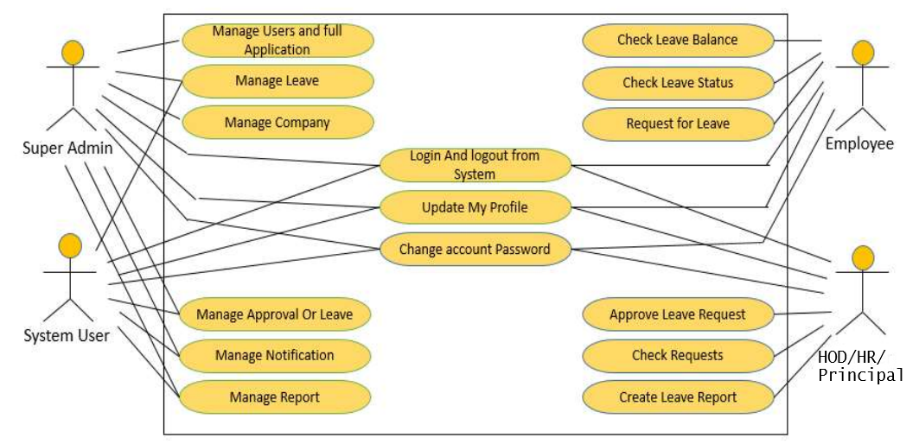

Fig. Use-Case Diagram of Employee Leave Management System

A use case diagram is used to represent the dynamic behavior of a system. It encapsulates the system's functionality by incorporating use cases, actors, and their relationships. It models the tasks, services, and functions required by a system/subsystem of an application. It depicts the high-level functionality of a system and also tells how the user handles a system.

The main purpose of a use case diagram is to portray the dynamic aspect of a system. It accumulates the system's requirement, which includes both internal as well as external influences. It invokes persons, use cases, and several things that invoke the actors and elements accountable for the implementation of use case diagrams. It represents how an entity from the external environment can interact with a part of the system.

It is essential to analyze the whole system before starting with drawing a use case diagram, and then the system's functionalities are found and once every single functionality is identified, they are then transformed into the use cases to be used in the use case diagram.

3.3 USE-CASE DESCRIPTION

The use case model for any system consists of “use cases”. Use cases represent different ways in which the system can be used by the user. A simple way to find all the use case of a system is to ask the questions “What the user can do using the system?” The use cases partition the system behavior into transactions such that each transaction performs some useful action from the users’ point of view.

The purpose of the use case to define a piece of coherent behaviour without revealing the internal structure of the system.An use case typically represents a sequence of interaction between the user and the system. These interactions consists of one main line sequence is represent the normal interaction between the user and the system. The use case model is an important analysis and design artifact (task).Use cases can be represented by drawing a use case diagram and writing an accompany text elaborating the drawing.

In the use case diagram each use case is represented by an ellipse with the name of use case written inside the ellipse. All the ellipses of the system are enclosed with in a rectangle which represents the system boundary. The name of the system being moduled appears inside the rectangle. The different users of the system are represented by using stick person icon. The stick person icon is normally referred to as an Actor. The line connecting the actor and the use cases is called the communication relationship.

3.4 SEQUENCE DIAGRAM

Sequence Diagram is an interaction diagram that details how operations are carried out what messages are sent and when. Sequence diagrams are organized according to time. The time progresses as you go down the page. The objects involved in the operation are listed from left to right according to when they take part in the message sequence.

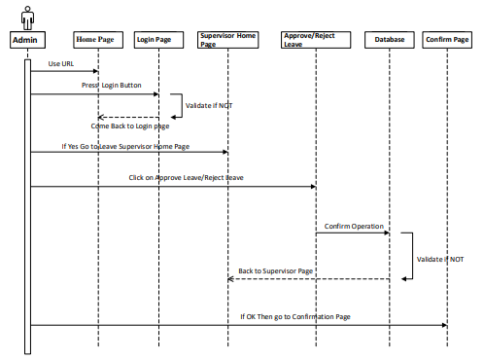
Fig. Sequence Diagram of Leave Management System

This is the Login Sequence Diagram of Leave Management System, where admin will be able to login in their account using their credentials. After
login user can manage all the operations on Approve Leave, Leave, Notification, Branch, Company. All the pages such as Notification, Branch,
Company are secure and user can access these page after login. The diagram below helps demonstrate how the login page works in a Leave
Management System.

This is the UML sequence diagram of Leave Management System which shows the interaction between the objects of Leave, Notification, Approve Leave, Company, Branch. The instance of class objects involved in this UML Sequence Diagram of Leave Management System are as follows:-

• Leave Object
• Notification Object
• Approve Leave Object
3.5 ACTIVITY DIAGRAM

Activity diagram is another important diagram in UML to describe the dynamic aspects of the system. It is basically a flowchart to represent the flow from one activity to another activity. The activity can be described as an operation of the system.

The control flow is drawn from one operation to another. This flow can be sequential, branched, or concurrent. Activity diagrams deal with all type of flow control by using different elements such as fork, join, etc. It captures the dynamic behavior of the system. Other four diagrams are used to show the message flow from one object to another but activity diagram is used to show message flow from one activity to another.

This is the Activity UML diagram of Leave Management System which shows the flows between the activity of Cancel Leave, Report, Approve
Leave, Leave, Notification. The main activity involved in this UML Activity Diagram of Leave Management System are as follows:-

• Cancel Leave Activity
• Report Activity
•Approve Leave Activity
• Leave Activity
• Notification Activity

Features Of The Activity UML Diagram Of Leave Management System:-

• Admin User can search Cancel Leave, view description of a selected
Cancel Leave, add Cancel Leave, update Cancel Leave and delete Cancel
Leave.

• Its shows the activity flow of editing, adding and updating of Report.

• User will be able to search and generate report of Approve Leave, Leave,
Notification.

• All objects such as (Cancel Leave, Notification) are interlinked
Its shows the full description and flow of Cancel Leave, Leave,
Notification, Approve Leave.

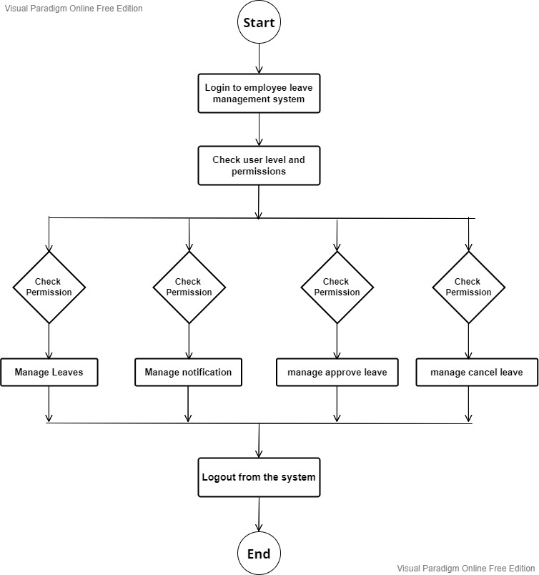

Fig. Activity Diagram of Employee Leave Management System
CHAPTER 4
DESIGN

4.1 OBJECT ORIENTED DESIGN

4.2 SYSTEM FLOW DIAGRAM

A system flowchart shows the path taken by data in a system and the decisions made during different levels. Different symbols are strung together to show data flow, including what happens to data and where it goes.
It is mainly used for physical modeling of the system showing inputs, outputs, and processes. Analysts frequently use them to illustrate the whole system graphically.

These flowcharts show physical control or resource level control. These flowcharts show data flow, but unlike data flowcharts, it also shows how decisions can control events. It shows data flow through major components like data entry, programs, storage media, and processes.

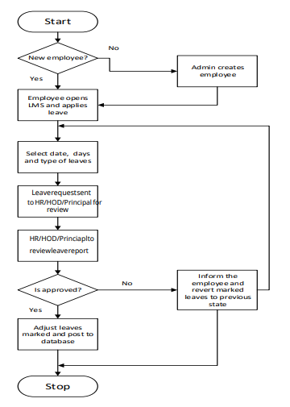

4.3 CLASS DIAGRAM

4.4 CLASS DESCRIPTION
4.5 DATA MODEL

4.5.1 DATA FLOW DIAGRAMS (DFD)

A data flow diagram is graphical tool used to describe and analyze movement of data through a system. These are the central tool and the basis from which the other components are developed. The transformation of data from input to output, through processed, may be described logically and independently of physical components associated with the system. These are known as the logical data flow diagrams. The physical data flow diagrams show the actual implements and movement of data between people, departments and workstations. A full description of a system actually consists of a set of data flow diagrams. Process is further identified with a number that will be used for identification purpose.

The development of DFD’S is done in several levels. Each process in lower level diagrams can be broken down into a more detailed DFD in the next level. The top-level diagram is often called context diagram. It consists a single process bit, which plays vital role in studying the current system. The process in the context level diagram is exploded into other process at the first level DFD. The idea behind the explosion of a process into more process is that understanding at one level of detail is exploded into greater detail at the next level.

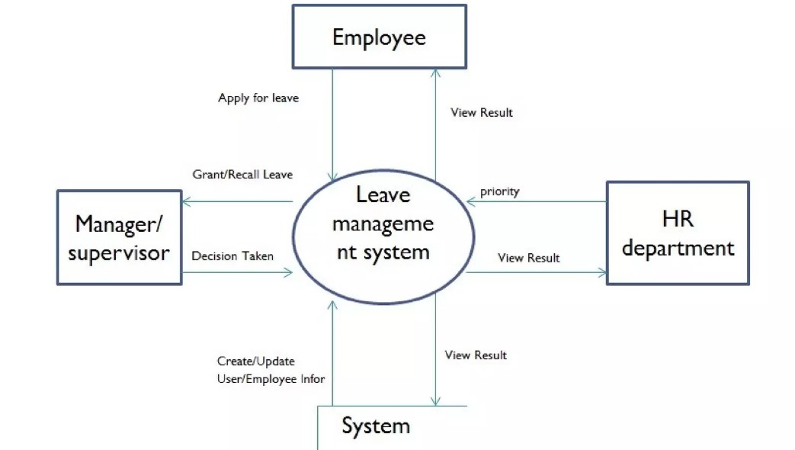
System

Fig. DFD of Employee Leave Management System
4.5.2 ENTITY RELATIONSHIP DIAGRAM (ERD)

